Graph:

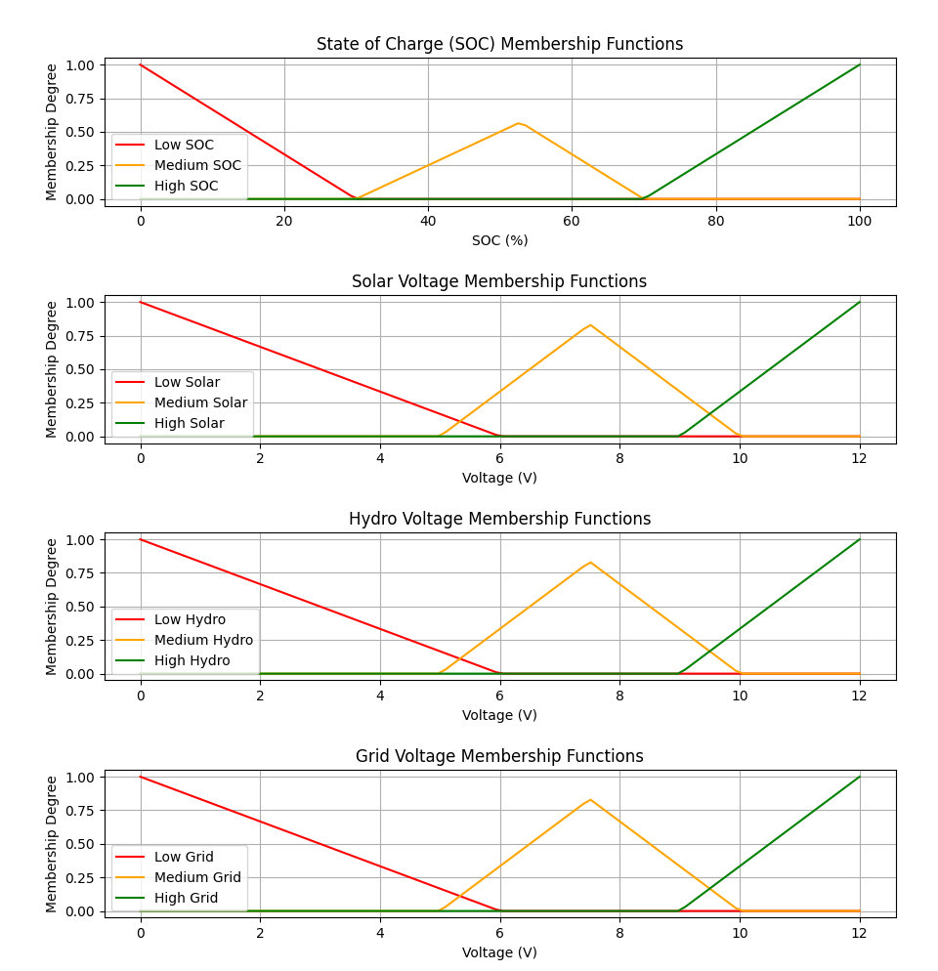

What’s inconsistent with this. At 100 SOC, all the sources are high. Which should not be the case, at 100%SOC in the 1 membership degree, dapat mag roll off pababa yung mga sources.

Similar to this one:  
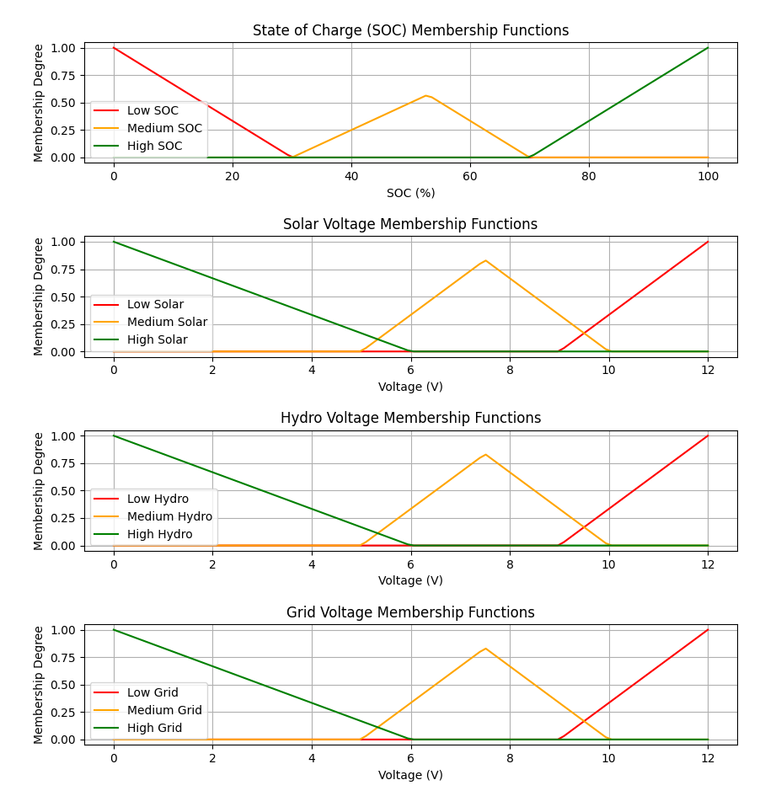

Going back to our table:

|  |  |  |  |
| --- | --- | --- | --- |
| %SOC | Vmin | Vmax | **Vbat** |
| 100 | 11.5 | 13.7 | 13.7 |
| 90 | 11.5 | 13.7 | 13.48 |
| 80 | 11.5 | 13.7 | 13.26 |
| 70 | 11.5 | 13.7 | 13.04 |
| 60 | 11.5 | 13.7 | 12.82 |
| 50 | 11.5 | 13.7 | 12.6 |
| 40 | 11.5 | 13.7 | 12.38 |
| 30 | 11.5 | 13.7 | 12.16 |
| 20 | 11.5 | 13.7 | 11.94 |
| 10 | 11.5 | 13.7 | 11.72 |
| 0 | 11.5 | 13.7 | 11.5 |

From Chatgpt:

**Output Voltage Variation Based on Input Voltage:**

1. **Input Voltage Range**: The XL4016 typically accepts an input voltage range of **4.5V to 40V**. However, the output voltage must always be lower than the input voltage for it to function correctly.
2. **Output Voltage Setting**:
   * The output voltage of the XL4016 can be adjusted by changing the resistors in the feedback loop. It has an onboard potentiometer that allows you to set the desired output voltage within the specified range (usually 1.25V to 36V).
   * The output voltage can be set to a constant value as long as the input voltage is greater than the output voltage.
3. **Load Regulation**: The output voltage may vary slightly with changes in load current due to load regulation characteristics. However, it is designed to maintain a relatively stable output voltage.

• **onstant Voltage Output**: Yes, you can configure the XL4016 to provide a constant output voltage. Once you set the desired output voltage using the onboard potentiometer, the regulator will attempt to maintain that output voltage as long as:

* The input voltage is sufficiently higher than the output voltage (at least 1.5V to 2V higher).
* The load does not exceed the maximum current rating of the XL4016 (up to 5A).

• **Feedback Mechanism**: The XL4016 utilizes a feedback mechanism to adjust its output. When the output voltage decreases (due to an increase in load or a drop in input voltage), the controller compensates by adjusting the duty cycle of the switching transistor, increasing the output voltage back to the set point.

**xample Scenario:**

* **Input Voltage**: 15V
* **Desired Output Voltage**: 12V
* **Load Current**: 2A

In this scenario, as long as the input voltage remains at 15V and the load current is at or below 5A, the XL4016 can output a constant 12V. However, if the input voltage drops to 11V, the XL4016 will not be able to maintain 12V output.

Ruleset:

|  |  |  |  |  |
| --- | --- | --- | --- | --- |
| **Grid** | **Solar** | **Hydro** | **SoC** | **Rule/Corrective Action** |
| NI | NI | NI | NC | Grid should turn on to Low (L) to maintain basic power. |
| NI | NI | L | Low | Grid should turn on to Medium (M) to supplement hydro. |
| NI | NI | M | Low | Grid should turn on to Low (L) for partial support. |
| NI | NI | H | Medium | No action needed, hydro is sufficient. |
| NI | L | NI | Low | Grid should turn on to Medium (M) to support charging. |
| NI | L | L | Low | Grid should turn on to High (H) to compensate for low power. |
| NI | L | M | Medium | Grid should turn on to Medium (M) for moderate support. |
| NI | L | H | Medium | Grid should stay off, hydro and solar are enough. |
| NI | M | NI | Low | Grid should turn on to Medium (M) to supplement solar. |
| NI | M | L | Low | Grid should turn on to Medium (M) to maintain charge. |
| NI | M | M | Medium | Grid should turn on to Low (L) if necessary for support. |
| NI | M | H | Medium | Grid stays off, hydro and solar meet demand. |
| NI | H | NI | Medium | Grid stays off, solar is sufficient. |
| NI | H | L | Medium | Grid stays off, solar supports most demand. |
| NI | H | M | Medium | Grid stays off, solar and hydro are sufficient. |
| NI | H | H | High | Grid stays off, full charge provided by solar/hydro. |
| L | NI | NI | Low | Grid should turn on to High (H) to provide power. |
| L | NI | L | Low | Grid should turn on to High (H) to provide power. |
| L | NI | M | Low | Grid should turn on to Medium (M) to support hydro. |
| L | NI | H | Medium | Grid should stay at Low (L), hydro mostly covers demand. |
| L | L | NI | Low | Grid should turn on to Medium (M) to support solar. |
| L | L | L | Medium | Grid should turn on to High (H) to ensure charge stability. |
| L | L | M | Medium | Grid stays at Low (L), solar and hydro are contributing. |
| L | L | H | Medium | Grid stays at Low (L), solar and hydro cover most needs. |
| L | M | NI | Medium | Grid stays at Low (L), solar supports demand. |
| L | M | L | Medium | Grid stays at Low (L) for support, solar and hydro contribute. |
| L | M | M | Medium | Grid stays at Low (L), solar and hydro are sufficient. |
| L | M | H | High | Grid can turn off as solar and hydro are adequate. |
| L | H | NI | Medium | Grid stays at Low (L), solar provides enough power. |
| L | H | L | Medium | Grid stays at Low (L), solar supports most needs. |
| L | H | M | Medium | Grid stays at Low (L), solar and hydro support load. |
| L | H | H | High | Grid can turn off, solar and hydro fully charge system. |
| M | NI | NI | Low | Grid stays at Medium (M) to provide stable power. |
| M | NI | L | Medium | Grid stays at Medium (M), hydro supports slightly. |
| M | NI | M | Medium | Grid stays at Medium (M), hydro supports demand. |
| M | NI | H | High | Grid turns to Low (L), hydro is sufficient for load. |
| M | L | NI | Medium | Grid stays at Medium (M), solar provides some support. |
| M | L | L | Medium | Grid stays at Medium (M), but provides majority power. |
| M | L | M | Medium | Grid stays at Medium (M), hydro supplements solar. |
| M | L | H | High | Grid turns to Low (L), hydro and solar meet demand. |
| M | M | NI | Medium | Grid stays at Medium (M), solar covers most of the demand. |
| M | M | L | Medium | Grid stays at Medium (M), solar and hydro support demand. |
| M | M | M | High | Grid turns to Low (L), solar and hydro are sufficient. |
| M | M | H | High | Grid turns to Low (L) or stays off, full charge from solar/hydro. |
| M | H | NI | Medium | Grid stays at Medium (M), solar provides sufficient power. |
| M | H | L | Medium | Grid stays at Medium (M), solar covers most of the demand. |
| M | H | M | High | Grid turns to Low (L), solar and hydro meet demand. |
| M | H | H | High | Grid turns to Low (L) or off, solar/hydro fully charge system. |
| H | NI | NI | Medium | Grid stays at High (H) to provide most of the power. |
| H | NI | L | Medium | Grid stays at High (H), hydro provides partial support. |
| H | NI | M | High | Grid turns to Medium (M), hydro supports demand. |
| H | NI | H | High | Grid turns to Low (L), hydro is sufficient. |
| H | L | NI | Medium | Grid stays at High (H), solar provides some support. |
| H | L | L | Medium | Grid stays at High (H), grid is primary power source. |
| H | L | M | High | Grid turns to Medium (M), solar/hydro support demand. |
| H | L | H | High | Grid turns to Low (L) or off, solar/hydro meet demand. |
| H | M | NI | Medium | Grid stays at High (H), solar supports the load. |
| H | M | L | Medium | Grid stays at High (H), solar and hydro support demand. |
| H | M | M | High | Grid turns to Medium (M), solar/hydro are sufficient. |
| H | M | H | High | Grid turns to Low (L) or off, solar/hydro fully charge system. |
| H | H | NI | Medium | Grid stays at High (H), solar is the primary contributor. |
| H | H | L | Medium | Grid stays at High (H), solar supports the majority of load. |
| H | H | M | High | Grid turns to Low (L), solar/hydro cover demand. |
| H | H | H | High | Grid turns off, solar/hydro are sufficient to fully charge the system. |

Voltage range for each input:

**New Voltage Ranges (with 12V max):**

1. **Grid** (Maximum: 12V)
   * **NI: 0V**
   * **Low (L)**: 4V to 8V
   * **Medium (M)**: 8V to 10.5V
   * **High (H)**: 10.5V to 12V
2. **Solar** (Maximum: 12V)
   * **NI: 0 to 3.9V**
   * **Low (L)**: 4V to 8V (low sunlight)
   * **Medium (M)**: 8V to 10.5V (moderate sunlight)
   * **High (H)**: 10.5V to 12V (bright sunlight, peak generation)
3. **Hydro** (Maximum: 12V)
   * **NI: 0 to 3.9V**
   * **Low (L)**: 4V to 8V (minimal water flow)
   * **Medium (M)**: 8V to 10.5V (moderate water flow)
   * **High (H)**: 10.5V to 12V (strong water flow)

**Minimum lower part of Low for each source (below 12V buck converter turns off): 4V**

**Less than 4V is considered as NI**

**NI means that the Grid is set to High, if available.**

**If voltage sensor of battery checks voltage to be 12V then cutoff the battery using relay.**

**NOTE: We will not let the summation of voltages be 36V**

**At least two sources are on to support charging to battery. Only exception is first condition that only Grid is available**

**Modifying table above:  
-reason: ruleset doesn’t take into consideration NI for only one state of SOC,which is NC**

|  |  |  |  |  |
| --- | --- | --- | --- | --- |
| **Condition** | | | | **Ruleset Action** |
| **Grid** | **Solar** | **Hydro** | **SoC** | **Rule/Corrective Action** |
| NI | NI | NI | NC | Grid should turn on to High (H) to maintain basic power. (if available) |
| NI | NI | NI | Low | Grid should turn on to High (H) to maintain basic power (if available). |
| NI | NI | NI | Medium | Grid should turn on to High (H) to maintain basic power (if available). |
| NI | NI | NI | High | Grid should turn on to High (H) to maintain basic power (if available). |
| NI | NI | L | NC | Grid should turn on to High (H) to supplement hydro. (if available). |
| NI | NI | L | Low | Grid should turn on to Medium (M) to supplement hydro. (if available). |
| NI | NI | L | Medium | Grid should turn on to Low (L) to supplement hydro. (if available). |
| NI | NI | L | High | Grid should turn on to Low (L) to supplement hydro. (if available). |
| NI | NI | M | NC | Grid should turn on to High (H) for partial support. |
| NI | NI | M | Low | Grid should turn on to Medium (M) for partial support. |
| NI | NI | M | Medium | Grid should turn on to Low (L) for partial support. |
| NI | NI | M | High | No action needed, hydro is sufficient. |
| NI | NI | H | NC | Grid should turn on to High (H) for partial support. |
| NI | NI | H | Low | Grid should turn on to Medium (M) for partial support. |
| NI | NI | H | Medium | No action needed, hydro is sufficient. |
| NI | NI | H | High | No action needed, hydro is sufficient. |
| NI | L | NI | Low | Grid should turn on to Medium (M) to support charging. |
| NI | L | L | Low | Grid should turn on to High (H) to compensate for low power. |
| NI | L | M | Medium | Grid should turn on to Medium (M) for moderate support. |
| NI | L | H | Medium | Grid should stay off, hydro and solar are enough. |
| NI | M | NI | Low | Grid should turn on to Medium (M) to supplement solar. |
| NI | M | L | Low | Grid should turn on to Medium (M) to maintain charge. |
| NI | M | M | Medium | Grid should turn on to Low (L) if necessary for support. |
| NI | M | H | Medium | Grid stays off, hydro and solar meet demand. |
| NI | H | NI | Medium | Grid stays off, solar is sufficient. |
| NI | H | L | Medium | Grid stays off, solar supports most demand. |
| NI | H | M | Medium | Grid stays off, solar and hydro are sufficient. |
| NI | H | H | High | Grid stays off, full charge provided by solar/hydro. |
| L | NI | NI | Low | Grid should turn on to High (H) to provide power. |
| L | NI | L | Low | Grid should turn on to High (H) to provide power. |
| L | NI | M | Low | Grid should turn on to Medium (M) to support hydro. |
| L | NI | H | Medium | Grid should stay at Low (L), hydro mostly covers demand. |
| L | L | NI | Low | Grid should turn on to Medium (M) to support solar. |
| L | L | L | Medium | Grid should turn on to High (H) to ensure charge stability. |
| L | L | M | Medium | Grid stays at Low (L), solar and hydro are contributing. |
| L | L | H | Medium | Grid stays at Low (L), solar and hydro cover most needs. |
| L | M | NI | Medium | Grid stays at Low (L), solar supports demand. |
| L | M | L | Medium | Grid stays at Low (L) for support, solar and hydro contribute. |
| L | M | M | Medium | Grid stays at Low (L), solar and hydro are sufficient. |
| L | M | H | High | Grid can turn off as solar and hydro are adequate. |
| L | H | NI | Medium | Grid stays at Low (L), solar provides enough power. |
| L | H | L | Medium | Grid stays at Low (L), solar supports most needs. |
| L | H | M | Medium | Grid stays at Low (L), solar and hydro support load. |
| L | H | H | High | Grid can turn off, solar and hydro fully charge system. |
| M | NI | NI | Low | Grid stays at Medium (M) to provide stable power. |
| M | NI | L | Medium | Grid stays at Medium (M), hydro supports slightly. |
| M | NI | M | Medium | Grid stays at Medium (M), hydro supports demand. |
| M | NI | H | High | Grid turns to Low (L), hydro is sufficient for load. |
| M | L | NI | Medium | Grid stays at Medium (M), solar provides some support. |
| M | L | L | Medium | Grid stays at Medium (M), but provides majority power. |
| M | L | M | Medium | Grid stays at Medium (M), hydro supplements solar. |
| M | L | H | High | Grid turns to Low (L), hydro and solar meet demand. |
| M | M | NI | Medium | Grid stays at Medium (M), solar covers most of the demand. |
| M | M | L | Medium | Grid stays at Medium (M), solar and hydro support demand. |
| M | M | M | High | Grid turns to Low (L), solar and hydro are sufficient. |
| M | M | H | High | Grid turns to Low (L) or stays off, full charge from solar/hydro. |
| M | H | NI | Medium | Grid stays at Medium (M), solar provides sufficient power. |
| M | H | L | Medium | Grid stays at Medium (M), solar covers most of the demand. |
| M | H | M | High | Grid turns to Low (L), solar and hydro meet demand. |
| M | H | H | High | Grid turns to Low (L) or off, solar/hydro fully charge system. |
| H | NI | NI | Medium | Grid stays at High (H) to provide most of the power. |
| H | NI | L | Medium | Grid stays at High (H), hydro provides partial support. |
| H | NI | M | High | Grid turns to Medium (M), hydro supports demand. |
| H | NI | H | High | Grid turns to Low (L), hydro is sufficient. |
| H | L | NI | Medium | Grid stays at High (H), solar provides some support. |
| H | L | L | Medium | Grid stays at High (H), grid is primary power source. |
| H | L | M | High | Grid turns to Medium (M), solar/hydro support demand. |
| H | L | H | High | Grid turns to Low (L) or off, solar/hydro meet demand. |
| H | M | NI | Medium | Grid stays at High (H), solar supports the load. |
| H | M | L | Medium | Grid stays at High (H), solar and hydro support demand. |
| H | M | M | High | Grid turns to Medium (M), solar/hydro are sufficient. |
| H | M | H | High | Grid turns to Low (L) or off, solar/hydro fully charge system. |
| H | H | NI | Medium | Grid stays at High (H), solar is the primary contributor. |
| H | H | L | Medium | Grid stays at High (H), solar supports the majority of load. |
| H | H | M | High | Grid turns to Low (L), solar/hydro cover demand. |
| H | H | H | High | Grid turns off, solar/hydro are sufficient to fully charge the system. |